

* Pixel-based
  + Pros: Universally applicable
  + Cons: Requires estimation of many unknowns, requires physical constraints
* Block-based
  + Pros: Fixed partitions require no manual determination of regions, fewer unknowns than a pixel-based approach
  + Cons: Motion is discontinuous across block boundaries, causing blocking artifacts
* Mesh-based
  + Pros: Continuous motion across an object’s surface
  + Cons: Fails to capture motion discontinuities at boundaries between objects
* Global
  + Pros: Describes motion using few parameters
  + Cons: Is not adequate if there are multiple directions of motion in a scene

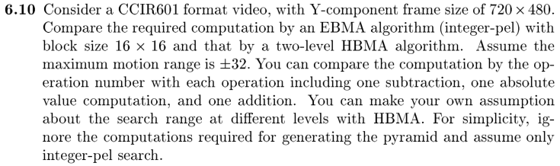

The required computation for EBMA can be broken down into several subsets of calculations:

1. The required computation to compare an anchor block to a target block using the MAD criterion.
2. The number of block comparisons with an entire search window. (One search window per anchor block.)
3. The number of anchor blocks within an entire anchor frame.

These subsets are summarized in the formulas below:

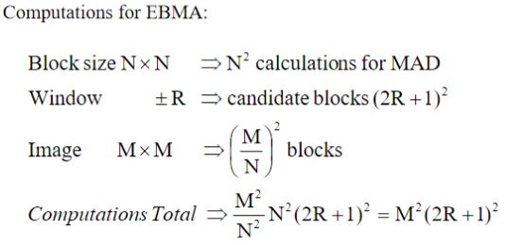

The specifications given in the question suggest N = 16 and R = 32. The image size, however, is not square, so our values are M1 = 720 and M2 = 480. This leads to a computation total of 720 x 480 x (2\*32+1)2 = 1,460,160,000 computations.

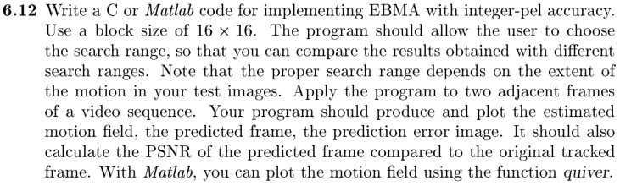

Results of this program using a 5x5 search window are displayed below.

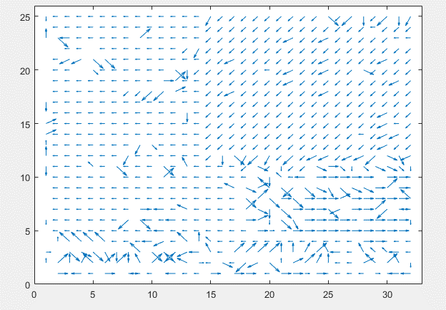

Figure : Estimated Motion Field

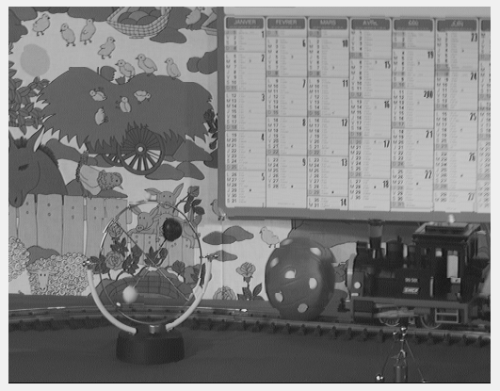

Figure : Predicted Frame

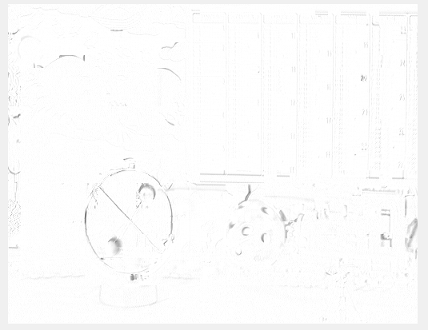

Figure : Error frame, complemented for easy viewing